Employee Self-Report of Accomplishments Overview



September 2010
Table of Contents
Self-Report of Accomplishments Overview 3
Understanding the Employee Self-Report of Accomplishments 3
Thinking About Your Work 4
Tracking Your Accomplishments 4
Documenting Your Performance 5
Self-Report of Accomplishments Entry Example 6
Self-Report of Accomplishments Entry Example 8
Self-Report of Accomplishments Resources & Training 9

Self-Report of Accomplishments Overview
This document includes:
- Key questions and answers about the self-report of accomplishments.
- Suggestions on how to document your accomplishments.
- Items to keep in mind when you are writing your employee self-report of accomplishments.
- One complete example that takes you through tracking your progress and writing an entry for a performance element.
- Two additional examples on how to write your self-report of accomplishments.

Understanding the Employee Self-Report of Accomplishments
What is the Self-Report of Accomplishments?
The Self-Report of Accomplishments is a narrative description of your accomplishments as it relates to your performance objectives, performance elements, organizational mission and goals, and other factors. The process consists of two parts:

- Tracking your accomplishments – This is done throughout the performance evaluation period.
- Documenting your performance – This is done before the mid-point review and the final evaluation.
Who should complete the Self-Report of Accomplishments?
The Self-Report of Accomplishments is your responsibility. As an employee, you have firsthand experience with what you have accomplished. Tracking your accomplishments ensures you capture the most important aspects of your performance. Documenting your performance provides you the important opportunity to represent yourself in your final evaluation.
When do I complete the Self-Report of Accomplishments?
Waiting until the end of the performance evaluation period to document your performance increases the likelihood of forgetting accomplishments or key details of how you achieved your performance objectives and demonstrated the performance elements. You may want to list accomplishments in the My Journal tab of the Performance Appraisal Application (PAA) Tool throughout the performance evaluation period.

How does my performance plan relate to my Self-Report of Accomplishments?
Your Performance Plan reflects your work priorities for the performance evaluation period by establishing expectations to meet organizational goals. Understanding these goals and expectations allows you to focus your actions and behaviors on meeting them. The targets and measures in your Performance Plan lend to the monitoring of your performance throughout the performance evaluation period against those expectations and identifying areas for improvement. Tracking your accomplishments helps you accomplish the mission goals and improve your performance. Writing up your accomplishments gives you a voice in your final evaluation.

Thinking About Your Work
Look at your performance plan…

- What are the measures, targets, and timelines for success?
- How is your supervisor tracking the successful accomplishment of performance objectives and performance elements?
- How is your performance impacting your organization?

Talk with your supervisor…

- If the answers to any of the questions above are unclear, meet with your supervisor to clarify expectations.
- Ask your supervisor about their expectations for the Self-Report of Accomplishments.

Tracking Your Accomplishments
There are a variety of ways to track your progress throughout the performance evaluation period. Consider the suggestions below to track your own accomplishments:
1. Use the My Journal tab in the PAA Tool
2. Utilize the DCIPS Employee Performance Journal located on the Army DCIPS website
  - Access the Army DCIPS website:
    - NIPRnet: http://www.dami.army.pentagon.mil/site/dcips/
    - SIPRnet: http://www.dami.army.smil.mil/site/dcips
    - JWICS: http://www.dami.ic.gov/site/dcips
  - Go to Documents in the left column and select Toolkits in the drop down menu
  - The DCIPS Employee Performance Journal can be found under the Performance Management heading
3. Use the Calendar or the Note functions in Microsoft® Outlook® to record accomplishments
4. Keep a journal of work accomplishments at your desk

Documenting Your Performance
Always remember…
- Don’t wait until the last minute - Writing your performance achievements takes the least amount of time when you track your accomplishment’s regularly.
- Restate your understanding of the performance objectives - List performance objectives, then group accomplishments under them.
- Address each performance objective individually – All of your performance objectives are important so make sure you address each of them.
- Include references to the performance elements - Make a list of the elements and check off each time that you demonstrate specific behaviors related to each element. Ensure that you have checked each element at least once.
- Highlight your most significant achievements for the appraisal period – Review the accomplishments you have tracked throughout the performance evaluation period and identify those that have had the largest impact on the organization.
- Make the connection between what you did and why it helps your organization- For each accomplishment, ask yourself, “How did I impact my organization?”
- Note challenges you faced and how you fared - Keep a journal of challenges and how you overcame them throughout the performance evaluation period.
- Include any additional accomplishments - Ask yourself, “What did I do above and beyond my objectives?”
Consider Using the STAR Method

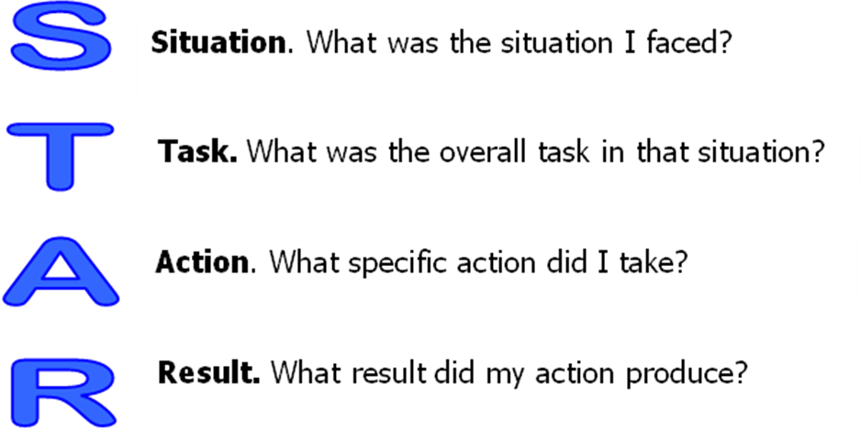
For each performance objective and performance element, write down the letters STAR and capture the aspects for each of the four dimensions. This allows you to collect the relevant information before phrasing it into sentences

Self-Report of Accomplishments Entry Example
Tracking Progress to Writing an Entry for a Performance Element
There are a variety of ways to track your progress throughout the performance evaluation period. The following example shows you how to track your accomplishments and how that translates to writing up entries for the performance objective and a performance element.
From Performance Objective…
Work Role: Travel Specialist, Pay Band 2
Performance Objective:
…process at least 80 percent of travel requests per month in accordance with standard operating procedures, with no more than one error per request and within 24 hours of receipt. Ensure that all obligated TDY funds are within the allocated fund cite budget...
…to Tracking Accomplishments Throughout the Performance evaluation period…
- Processed between 81 and 189 travel requests each month
- Percentage of requests with 0-1 errors at 85%
- Processed 87% of requests within 24 hours of receipt
- October was my best performance, with 132 requests that I processed on time (98%) with high accuracy (99%).
- For TDY fund obligations, I documented and implemented an additional step to the standard operating procedure to verify that funds are within the allocated fund cite budget prior to making the obligation.
…to Self-Report of Accomplishments Entry for Performance Objectives
Each month I processed between 81 and 189 travel requests. Of those, each month I had a percentage of requests with 0-1 errors at 85%. I processed 87% of the requests within 24 hours of receipt. I met my performance objective, even when I was on leave, by prioritizing my time. October was my best performance, with 132 requests that I processed on time (98%) with high accuracy (99%). For TDY fund obligations, I documented and implemented an additional step to the standard operating procedure to verify that funds are within the allocated fund site budget prior to making the obligation. I made this change in collaboration with travel specialists in other divisions. By implementing this step, I have been able to ensure that the obligations are proper, keeping the fund audit-ready.
…to Self-Report of Accomplishments Entry for Performance Elements
Critical Thinking: I was responsible for processing travel requests each month, ensuring that all obligated TDY funds were within the allocated fund cite budget. I documented and implemented an additional step to the standard operating procedure to verify that funds are within the allocated fund site budget prior to making the obligation. I made this change in collaboration with travel specialists in other divisions. By implementing this step, I have been able to ensure that the obligations are proper, keeping the fund audit-ready.

Self-Report of Accomplishments Entry Example
Paragraph Method & STAR Method
The method you use to track and write up your Self-Report of Accomplishments should be a combination of your personal preference and your supervisor’s preferences. It is important to talk to your supervisor to understand his or her expectations for your Self-Report of Accomplishments. You want to make sure both you and your supervisor have the same expectations for how the Self-Report of Accomplishments should look when it is finished.
What follows are two examples that show different work roles and alternative approaches to documenting your accomplishments.
Example 1
Paragraph Method
From Performance Objective…
Work Role: Intelligence Analyst, Pay Band 3
Performance Objective:
…analyze office procedures and policy documents to accurately identify agency obligations and anticipate intelligence trends, future needs, gaps/shortfalls, or problems. Provide reports and/or briefings at our weekly staff meetings or within requested timelines that accurately describe any problem you are solving, your recommended solution, and challenges you encountered during the resolution process. Solicited and unsolicited feedback will be considered to validate whether solutions satisfactorily met the partner mission requirement in terms of time and effectiveness…
…to Sample Self-Report of Accomplishment
Throughout FY2010, I provided 63 reports to internal and external partners and briefed at 18 weekly staff meetings on multiple facets of my assigned area. Of the 63 reports, 59 were completed within the requested timelines while the other four were delayed due to rapidly changing situational events beyond my control. I received 24 instances of positive feedback with comments that included: “Excellent job, reports directly improved decision advantage for our area” (1/15/2010), “Fantastic turnaround allowed us to take decisive action on the issue” (3/22/2010), “Briefing was comprehensive, well sourced and thoughtful. Well done.” (2/5/2010). In February 2010, I developed an improvement to agency policy documents and briefed my recommended changes to my supervisor on 18 February 2010. The recommendations were incorporated with minor changes on 1 July 2010. As a result, turnaround time was reduced by 25% throughout 4QFY10.
Example 2
S T A R Method
From Performance Objective…
Work Role: Program Management Officer, Pay Band 4
Performance Objective:
…capture, coordinate, and manage program risks. Document the risks and the risk management strategies in a Risk Management Plan. Generate the first working level coordinated draft of this plan by the end of 1QFY10. Generate and distribute the second/final draft by 2QFY10. This will include coordinating risks and communicating them to ODNI. Starting 2QFY10, communicate the Program risks internally and represent the Program to that board for 75% of their meetings.
…to Self-Report of Accomplishment
S – I am responsible for capturing, coordinating and managing program risks.
T – To accomplish this, I am responsible for documenting strategies in the Risk Management Plan in accordance with set milestones and then briefing these risks internally.
A – I completed the coordinated working-level draft by the end of 1QFY10, and I was able to generate and distribute the final draft by 1 February, ahead of my 2QFY10 milestone. I distributed the plan to key stakeholders with monthly updates for the remainder of FY09 and generated a communications schedule to represent the Program at board meetings. The schedule allowed me to brief at 85% of meetings, providing pertinent information and ongoing updates to the Program.
R – Strong collaborative efforts on the first draft resulted in a document that required limited rework, allowing the final draft to be completed ahead of schedule. I received positive feedback from 3 out of 5 of the key stakeholders. Ongoing updates gave the board the information it needed to make cost-saving adjustments to at least three programs in 3QFY10 and at least five programs in 4QFY10.

Self-Report of Accomplishments Resources & Training
- Army DCIPS website
  - NIPRnet: http://www.dami.army.pentagon.mil/site/dcips/
  - SIPRnet: http://www.dami.army.smil.mil/site/dcips
  - JWICS: http://www.dami.ic.gov/site/dcips
- iSuccess course which takes you through the steps of developing your performance objectives and your self-report of accomplishments
- Your Supervisor
- Your command’s DCIPS Transition Manager

  - DCIPS E-Mail Inbox
    - NIPRnet: DCIPS@us.army.mil
    - JWICS: DCIPS@dami.ic.gov
    - SIPRnet: DCIPS@dami.us.army.smil.mil

